- Product model: GIV-Dongle

- Name and address of the Authorised representative:
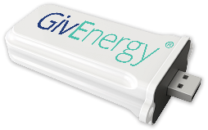
JMHing power Ltd
Unit 5 Towerhouse lane
Towerhouse industrial estate
Hedon
HU12 8EE
Telephone No. 01377 252874

- This declaration of conformity is issued under the sole responsibility of the manufacturer.

- Object of the declaration:

Equipment: 2.4GHz Wi-Fi Communication Device
Brand name: GivEnergy
Model/type: GIV-Dongle

- The object of the declaration described above is in conformity with the relevant Union harmonization legislations:

Radio Equipment Directive 2014/53/EU (RED)
The radio equipment directive 2014/53/EU (RED) establishes a regulatory framework for placing radio equipment on the market.

- References to the relevant harmonised standards used or references to the other technical specifications in relation to which conformity is declared:
RED 2014/53/EU: |  | EN 301 489-1 V2.1.1  EN 301 489-17 V3.1.1  EN 300 328 V2.1.1  EN 62311:2008

- Signed for and on behalf of:

Authorised representative:

JMHing Power Ltd
Unit 5 Towerhouse lane
Towerhouse industrial estate
Hedon
HU12 8EE
Telephone No. 01377 252874
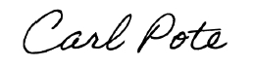
________________________________________
Carl Pote- Head of European operations
Burton on Trent, Staffordshire (05.06.2019)

